

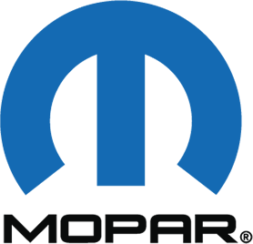
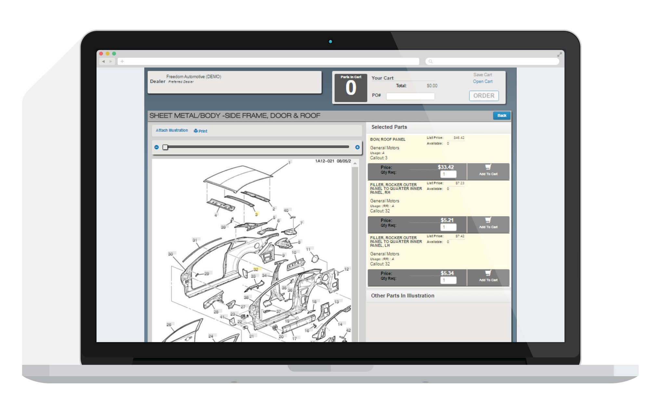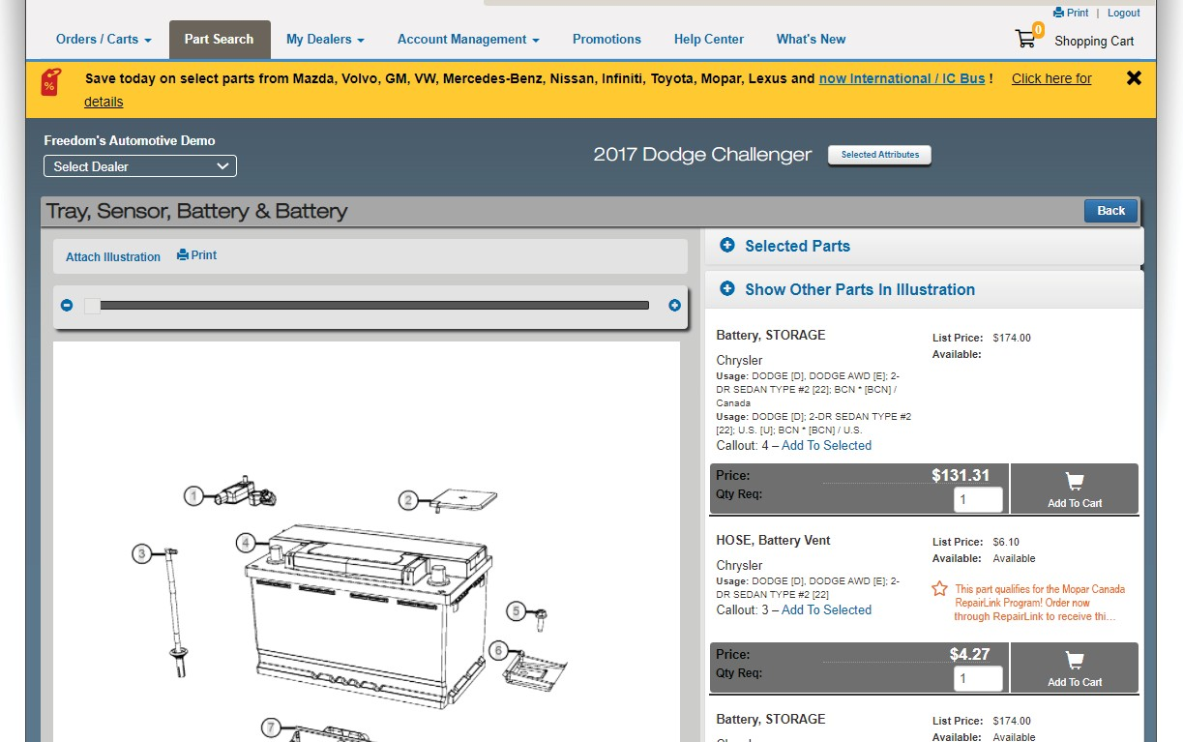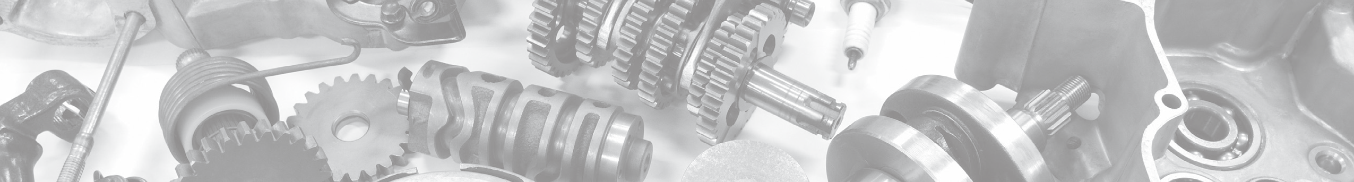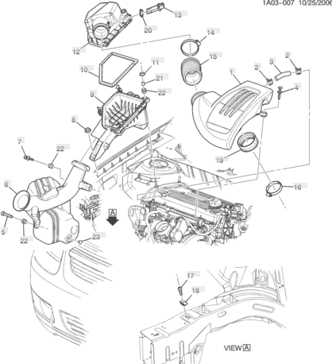
Free to your repair shop, RepairLinkSM delivers a complete electronic OE parts ordering system online with ease.
Not only do you have access to our dealership pricing and inventory availability; you can also view illustrations and technical diagrams of 23 OEMs, making RepairLinkShop.com
a valuable resource for your shop.
Order parts from us, online 24/7, at no additional cost!
•
•
•
VIN-based parts look-up
24/7 Online ordering with preferred dealerships
Best-in-class part illustrations and technical diagrams
Real-time online order updates
Tablet, mobile, and multi-browser friendly
•
•
Start using RepairLink today by visiting RepairLinkShop.com or call 888.776.5792 for more information.
Right Part. Right Place. Right Time.®
4205 Highlander Parkway, Richfield, OH 44286 | 1.888.776.5792 |
OEConnection.com

